Ultrasonic-Empowered Smart Manufacturing: A Comprehensive Review of CNC Ultrasonic Machining Technology

Preface

With the rapid upgrading of the jewelry, precision ceramic and hard-brittle material processing industries, conventional CNC machining has long been plagued by pain points when processing workpieces with high hardness and high brittleness, including edge chipping, severe tool wear, low yield rate and difficulty in reproducing micro textures. These issues restrict the mass production of workpieces with complex curved surfaces, relief carvings, scooped patterns and hollow structures.
CNC ultrasonic composite machining technology organically combines numerical control cutting with high-frequency ultrasonic vibration. Micro-meter high-frequency vibration is superimposed on traditional spindle rotation, transforming the cutting motion mechanism and greatly improving the machining performance of hard-brittle materials.
Targeting the multi-axis processing scenarios of the jewelry industry, Shenzhen Guanglijin Technology Co., Ltd. has independently developed patented CNC ultrasonic machining technology. By integrating ultrasonic modules into 5-axis and dual 5-axis CNC equipment, the technology effectively addresses challenges in precision machining of precious metal products, and accelerates the upgrading of jewelry manufacturing toward high precision and automation.
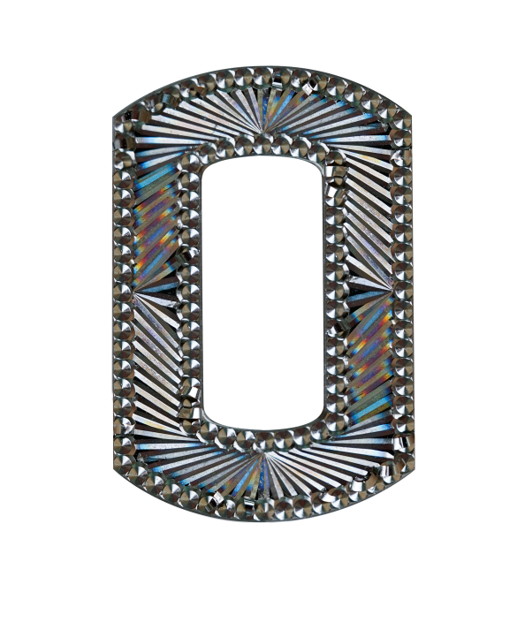

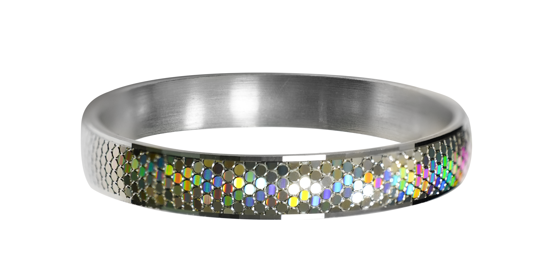

1. Basic Principles of CNC Ultrasonic Machining Technology
CNC ultrasonic machining does not break materials through ultrasonic impact. Instead, it is a vibration-assisted composite cutting process. By superimposing high-frequency and micro-amplitude vibration on the conventional CNC numerical control motion, the tool achieves periodic intermittent contact with the workpiece, which effectively optimizes the overall cutting state.

2. Core Technical Advantages of CNC Ultrasonic Machining
Compared with conventional CNC machining, ultrasonic composite machining boasts remarkable advantages in precision, yield rate, tool life and machining quality.

2.1 Effectively reduce cutting force and protect workpiece profile
Cutting force decreases by 30%–50%, lowering machining impact;
Greatly reduce edge and corner chipping, especially suitable for hard precious metals;
Thin-wall and micro relief structures are less prone to deformation and collapse during machining.

2.2 Improve surface machining quality and restore fine textures
Uniform and delicate machining traces with sharp lines for scooped patterns and relief carvings;
Less burrs and tool marks, reducing subsequent polishing workload under certain working conditions;
Enable stable mass production of complex curved surfaces, hollow structures and micro grooves.

2.3 Extend tool service life and cut production costs
Aleviate friction and wear of tools to achieve a notable increase in tool life;
Reduce frequent machine downtime for tool changes, raise equipment availability and suit mass production.

2.4 Compatible with multi-axis linkage with high process integration
Can be directly integrated into 5-axis and dual 5-axis CNC machines and support multi-axis linkage;
A single machine can complete multiple processes including milling, engraving, scooping and hollowing.

3. Main Applicable Machining Materials and Application Scenarios

3.1 Main Machinable Materials
Precious metals: Commonly used jewelry precious metals such as K gold, platinum and sterling silver;
Selected hard-brittle composite materials.

3.2 Typical Application Scenarios
Jewelry industry: Surface scooping, relief carving, hollow patterns and complex curved surface ornament machining for jewelry, which is the primary application scenario of this technology.

4. Practical Machining Cases
Scooping Machining of Precious Metals
Conventional scooping tends to produce uneven depth of patterns and surface burrs, resulting in heavy workload for subsequent polishing. Ultrasonic-assisted scooping delivers neat and distinct textures with drastically reduced burrs. The polishing working hours are cut by 40%, making it ideal for automated mass production of jewelry.

5. Notes on Technology Application
Conventional cutting parameters cannot be directly adopted for ultrasonic machining. The amplitude, spindle speed and feed rate shall be adjusted according to the workpiece material and cutting tool.
Tool condition directly determines the ultrasonic machining result. Severe tool wear will lead to a drop in finished product yield.
Materials with different hardness require matched amplitude ranges. Higher amplitude does not guarantee better machining performance.

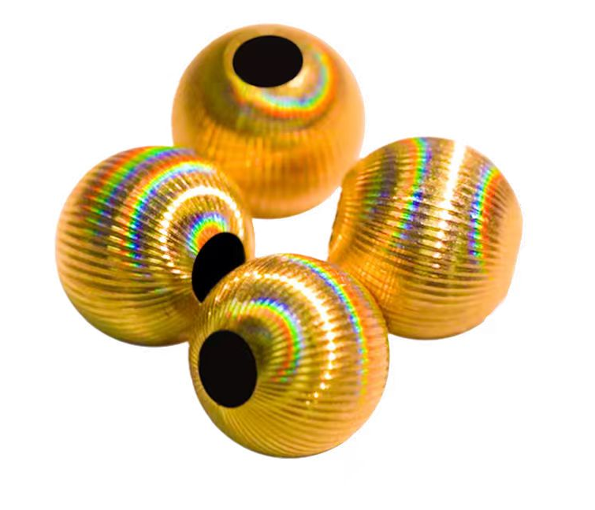


Conclusion
CNC ultrasonic composite machining is an enhancement and upgrade of traditional CNC machining process, rather than a full replacement. It transforms the cutting mechanism through high-frequency micro-vibration, and effectively solves industry bottlenecks in jewelry processing of hard-brittle materials, such as edge chipping, indistinct textures and low yield.
The CNC ultrasonic multi-axis composite machining technology mentioned herein is patented and independently developed by Shenzhen Guanglijin Technology Co., Ltd. The ultrasonic unit is deeply integrated into 5-axis and dual 5-axis jewelry CNC machines. The company delivers comprehensive automated machining solutions for the jewelry sector, supporting the industry’s transformation into high-precision, high-efficiency intelligent manufacturing.

